

General Information

01



Lumz Trading ( Pty )Ltd is company which based in Kwadukuza and is operating under the Kwadukuza Local Municipality and ILembe D district.The contact details of the company are as follows :

Sakhamkhanya Area

Doesburg Road

Kwadukuza

4450

Cell:081 361 7683

Email:lumzworks@gmail.com

# Company Registration Details

## Reg No: 2021 / 323083 / 07

 Tax Ref No:9359493203

MAAA 1019024

The company is actively trading and any other information can be obtained at the phone number the email address and to our social media contacts.

# Black Economic Empowerment

We are a BEE Level 1 Company

# Company Details

## Company Overview

Lumz Trading (Pty)Ltd was launched to be the leading service provider in our two different divisions.It has 100 % black shareholding.Our two divisins are:

1. Construction Works
2. Garden Services

01

Vision



02

To be the leading service provider of choice

# Mission

Our mission is to be a dynamic service provider that will provide reliable, quality, fast and efficient service to the customers and clients.

# Core Values

Accountability : We accept responsibility of our actions. We make and support business decisions

through experience and good judgement.

Customer Services : We are dedicated to satisfy customer and client needs and honoring

commitments that we have made to them.

Team Work: Our team is supportive of each other’s effort loyal to one another and care each other

personally and professionally.

Respect : We treat our team members, customers and clients with mutual respect and recognizing the

importance of diversity.

Integrity: We act with honesty and integrity not compromising the truth.

Passion For Results : We show pride, enthusiasm and dedication in everything we do. We are

committed in delivering high quality services.

## Construction Works

We do construction works for both domestic and industrial

Our Services



03



Electrical Plumbing

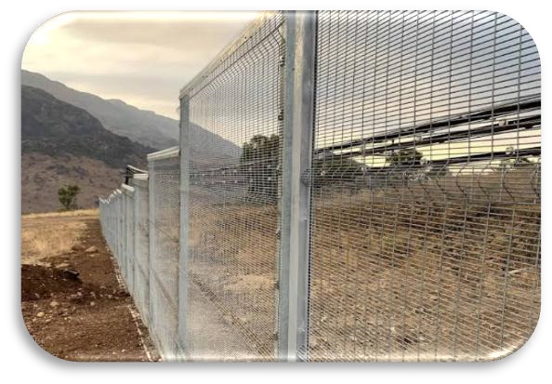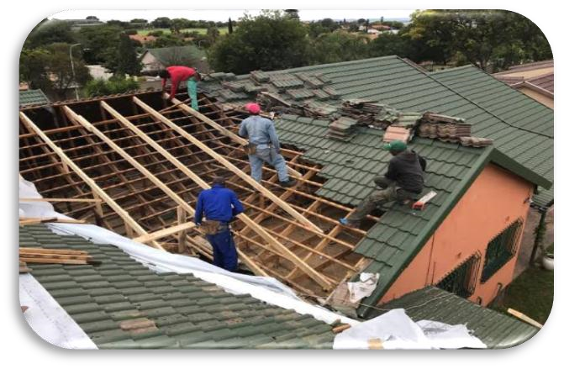

Fencing Roofing



04

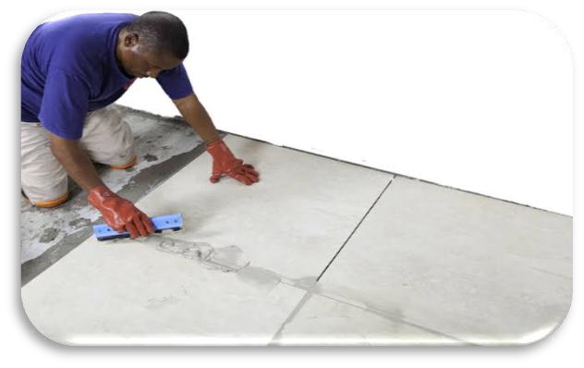

Glazing Tiling

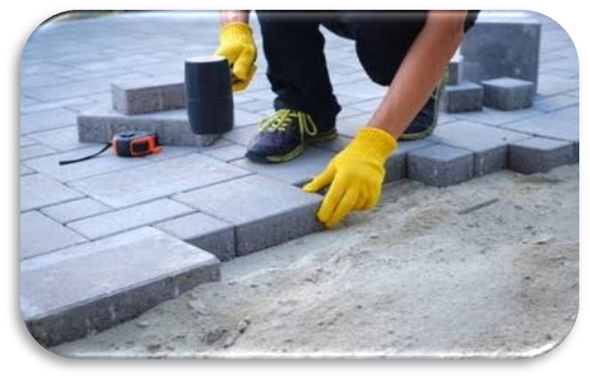



Welding Paving



05

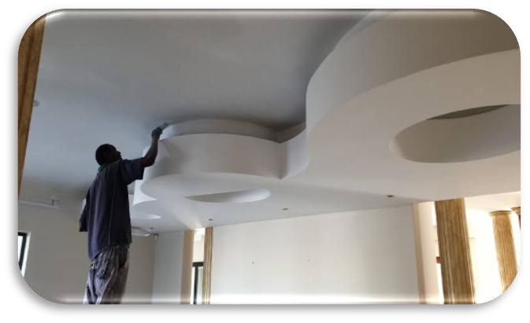

Brick Mansory Ceiling And Partition

# Garden Services



Our garden service department consist of grass cutting, trimming ,tree felling , yard cleaning and waste removal.



06

# Customers

Lumz trading is prepared to service any customers including small to large-sized private and public sector organizations.

# Contact Us



Sakhamkhanya Area Doesburg Road Kwadukuza 4450



## 081 361 7683



## lumzworks@gmail.com



Lumztrading 081 361 7683

